**if else questions**

**1) check whether the user is eligible for voting or not**

**2) check whether a number entered by user is even or odd**

**3) check whether a number entered by user is negative or positive**

**4) find the lowest and higest number out of 3 numbers entered by the user**

**5) accept the total bill amount from the user and display the final amount after applying the discount**

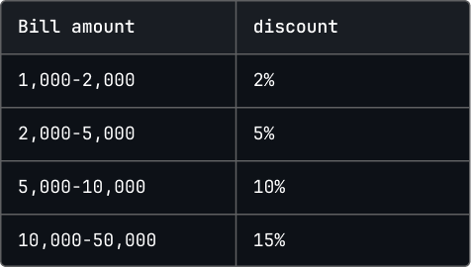

**6) write a Python program to calculate the total wage of a worker, which depends on the number of hours they worked. The worker earns Rs. 100 per hour, but if they work more than 40 hours, they will receive Rs. 200 for every extra hour.**